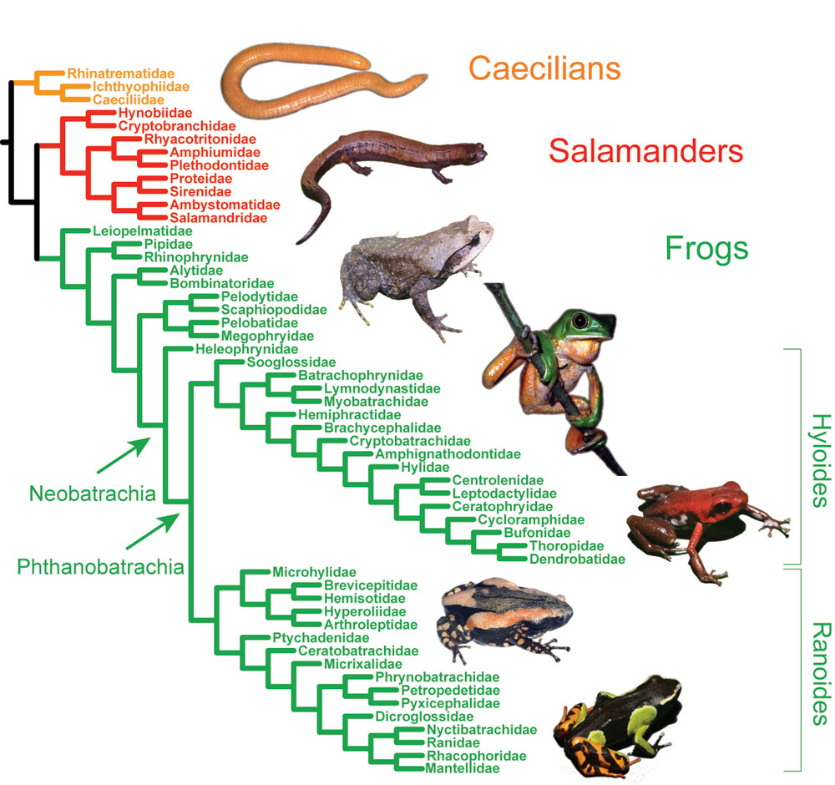

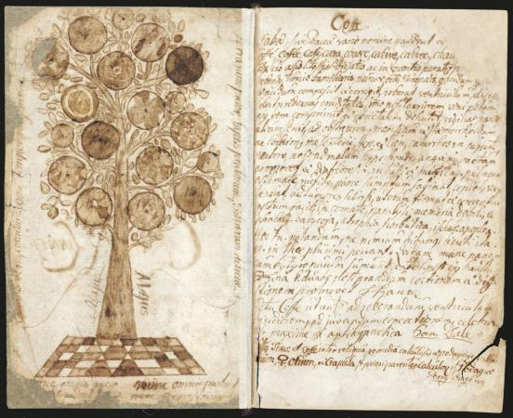
Linnaeus 1635

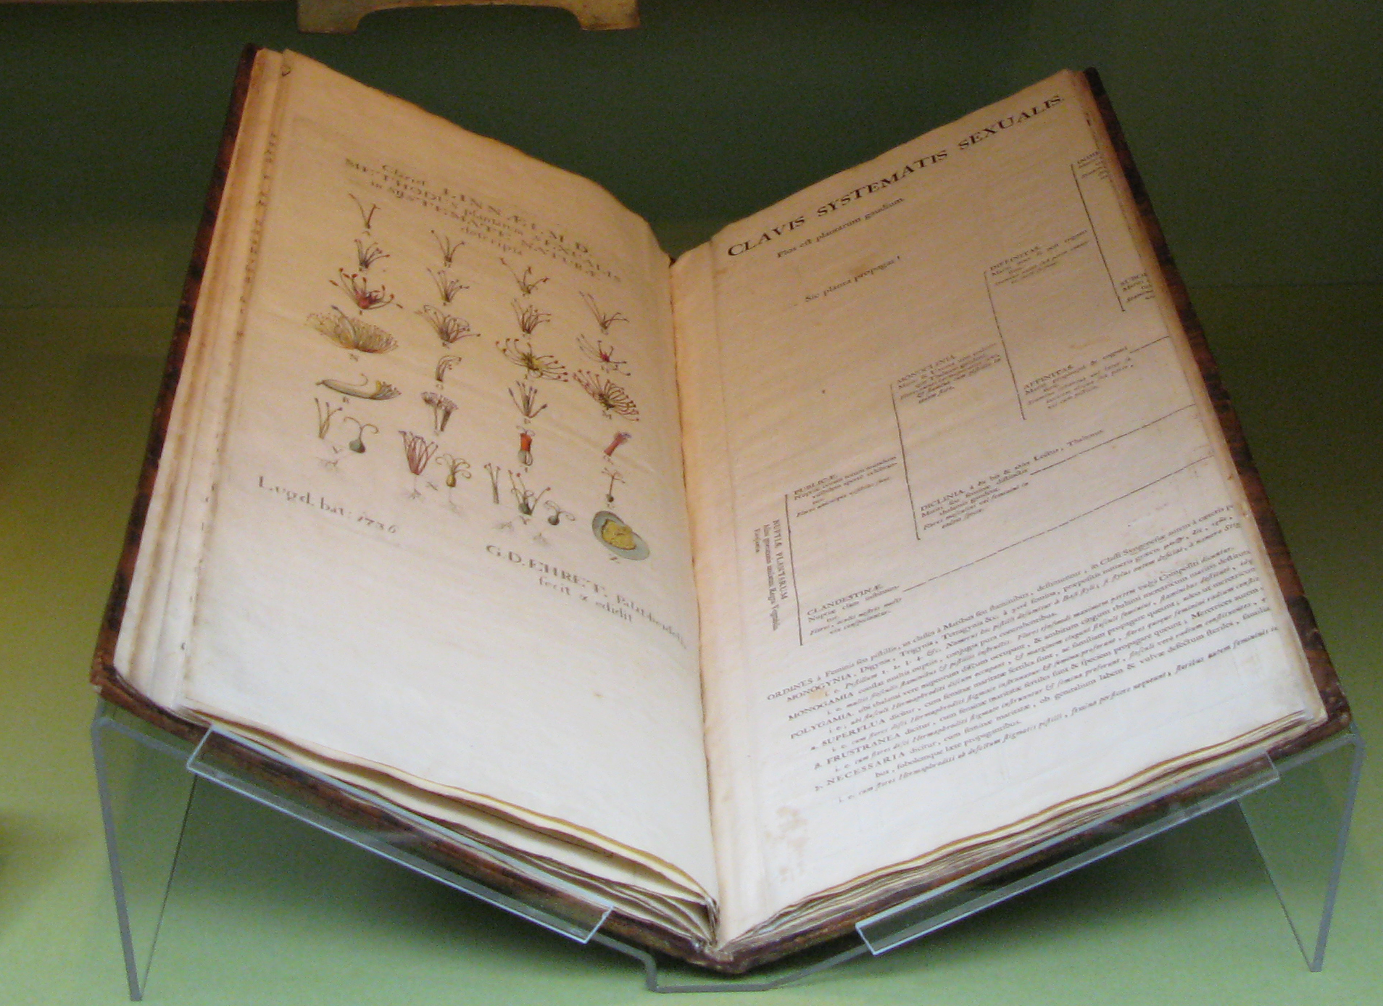
Linnaeus 1635

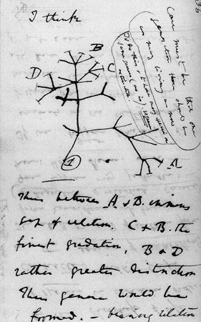

Darwin 1837
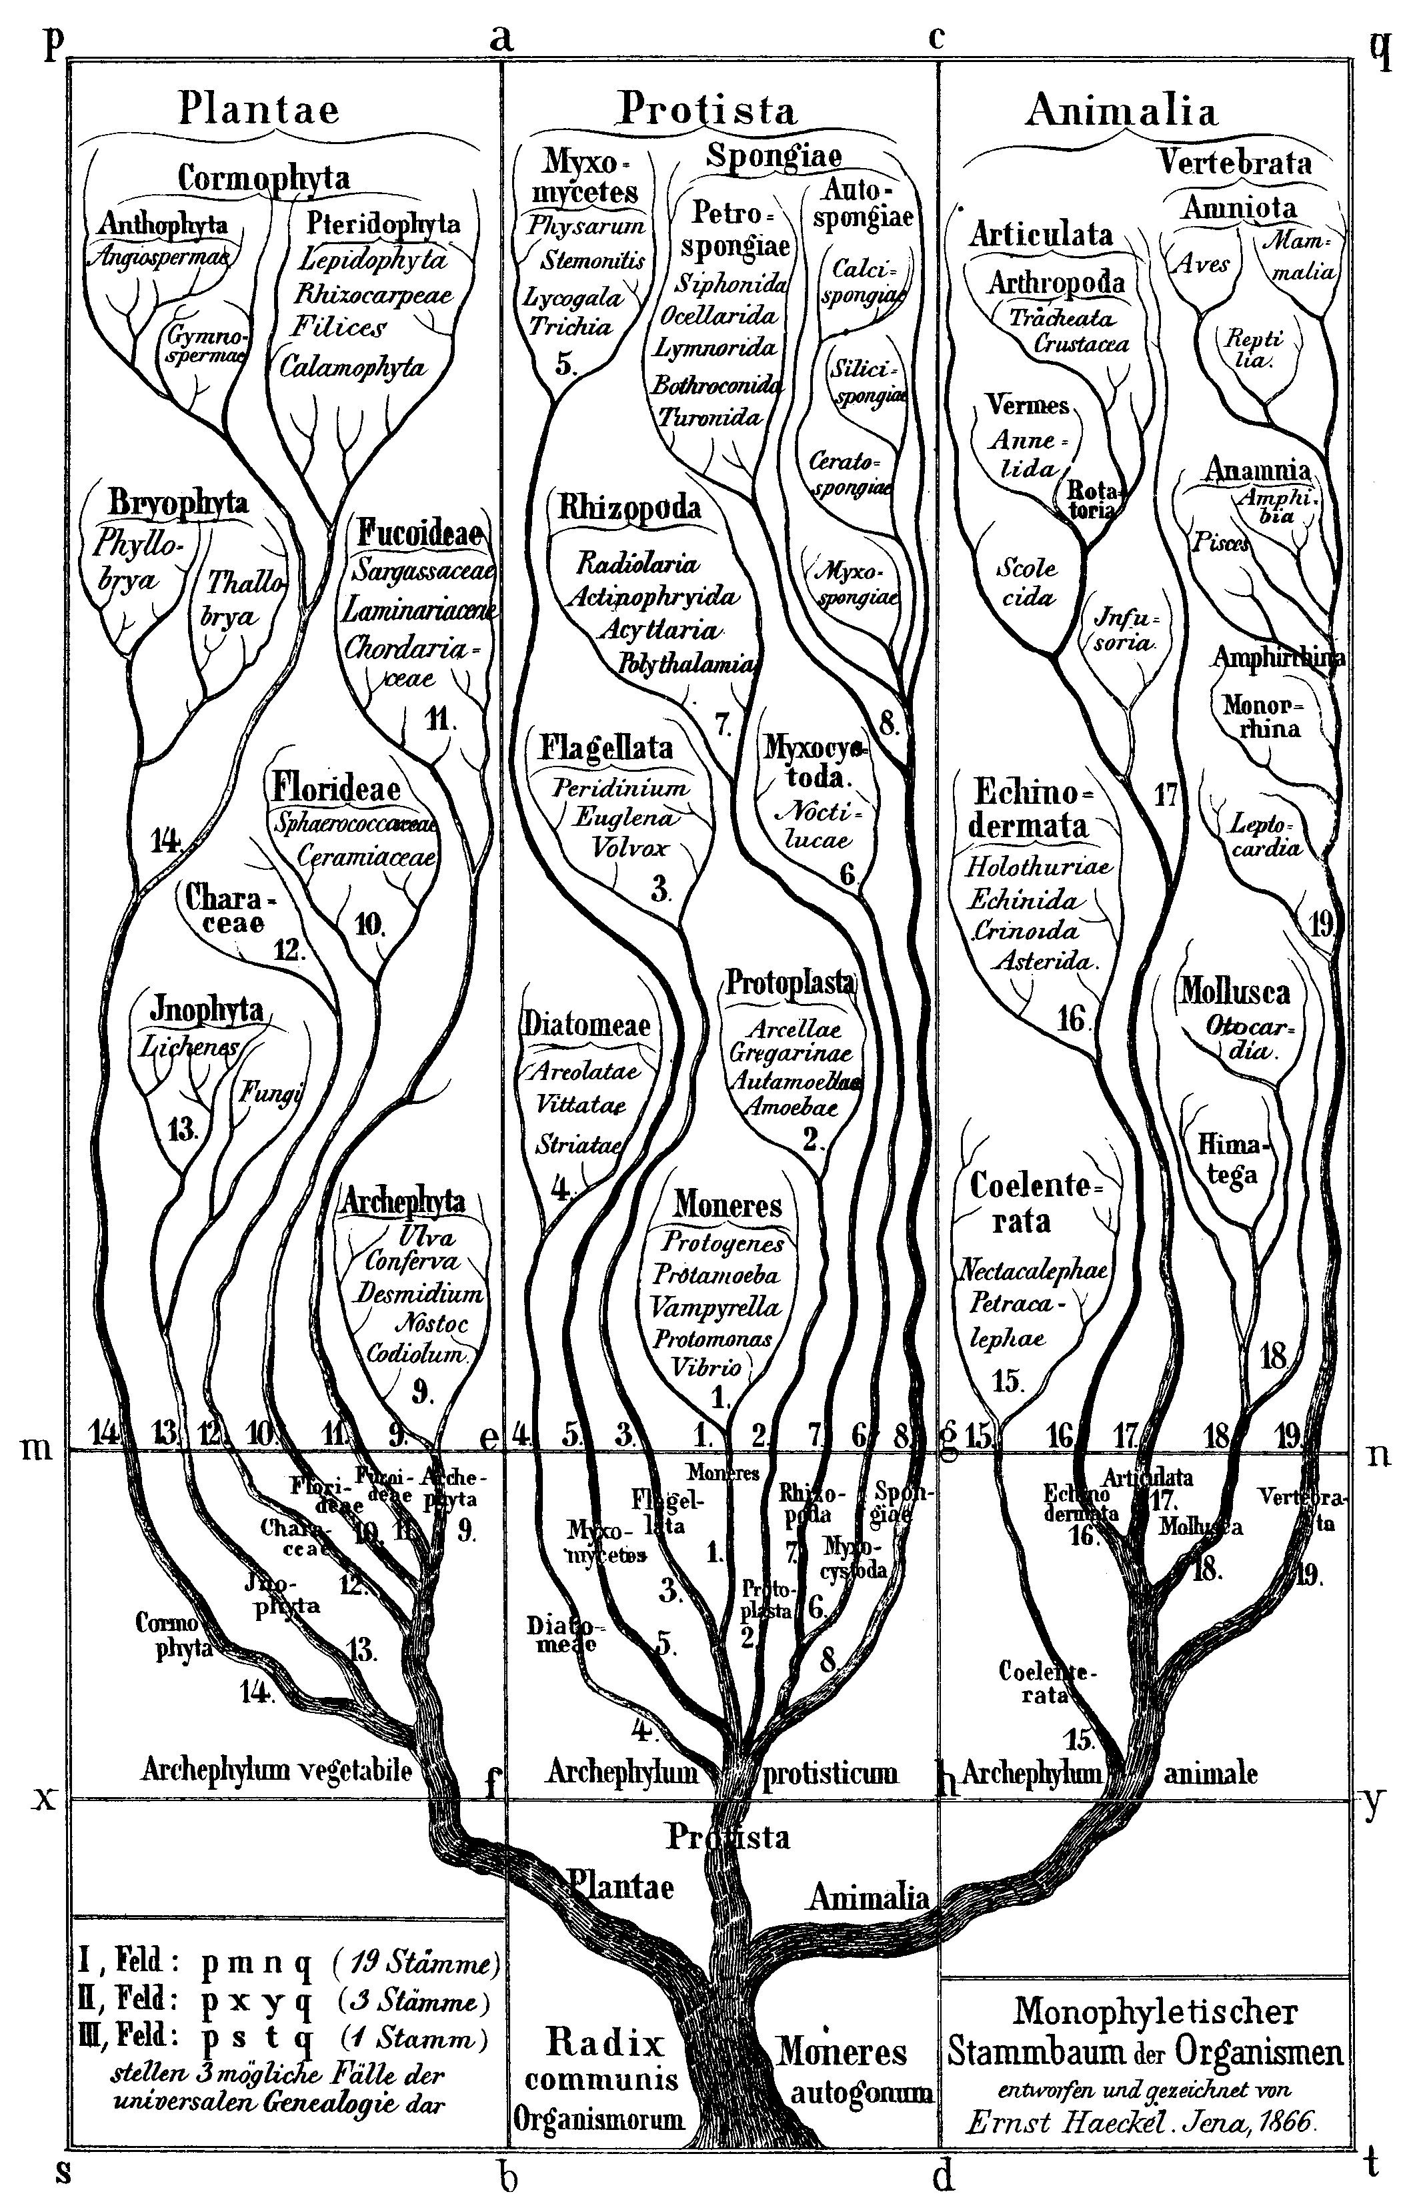
Haeckel 1866

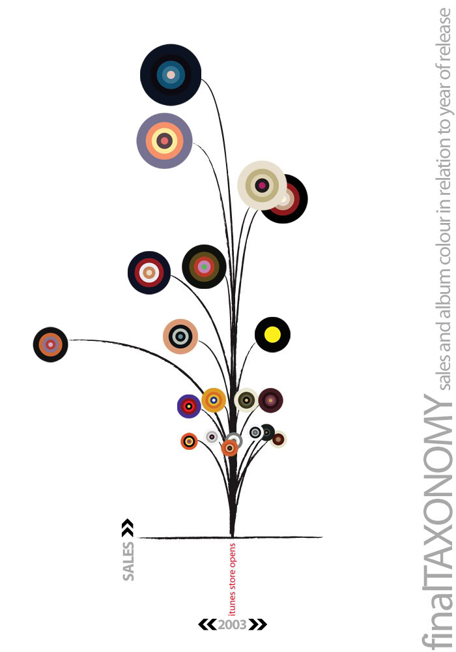

Madeline Zara Reader, 2008
http://infostudio2008.ning.com/profiles/blog/show?id=2009411%3ABlogPost%3A4682

Linnaeus 1635
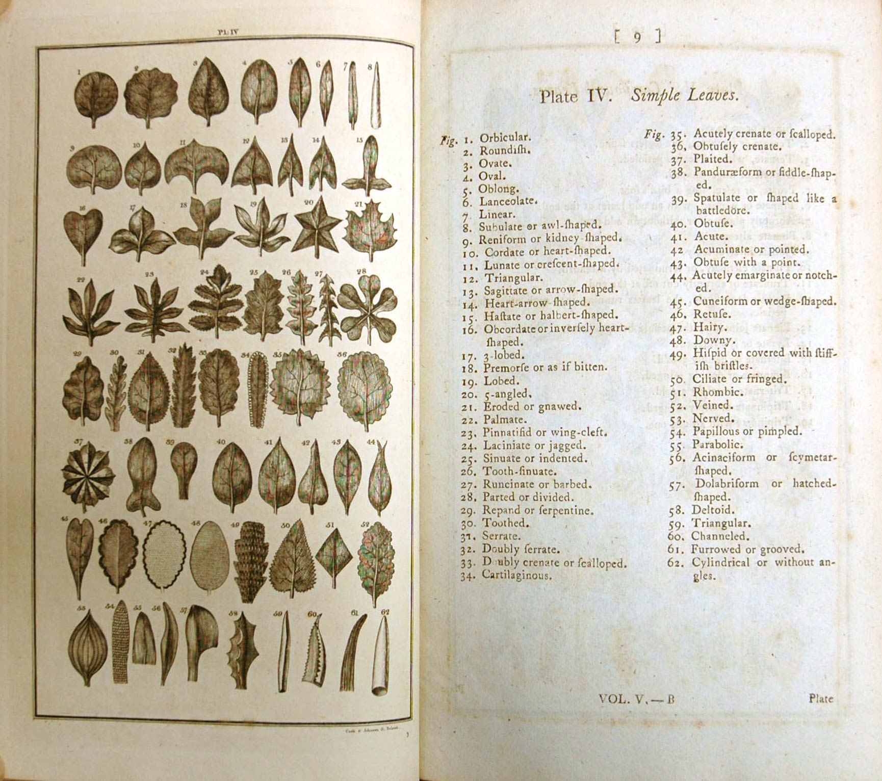
Linnaeus 1635



